Transmitter Module
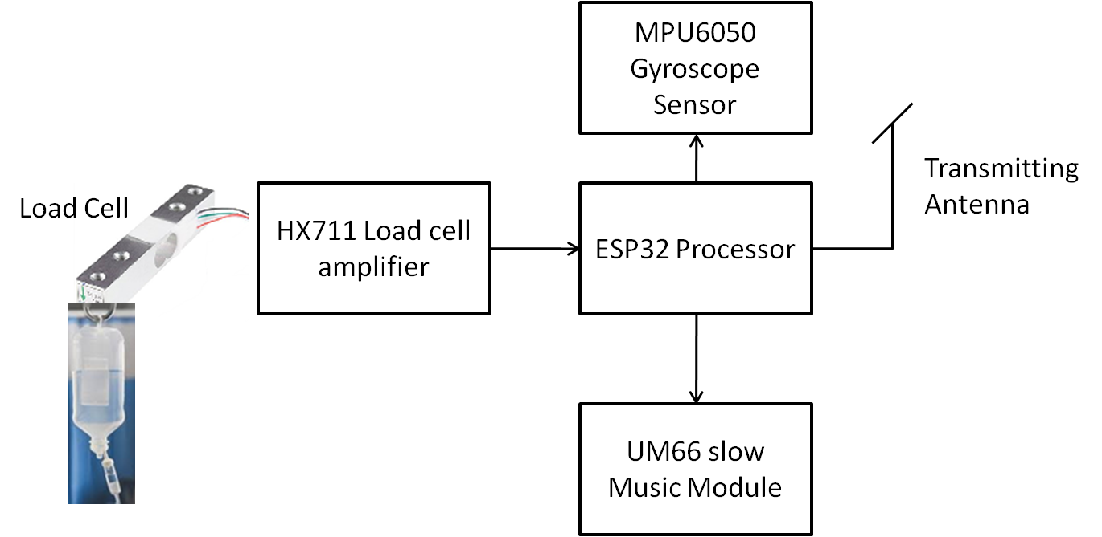
Fig1: Saline Level Indicator Transmitter Block Diagram

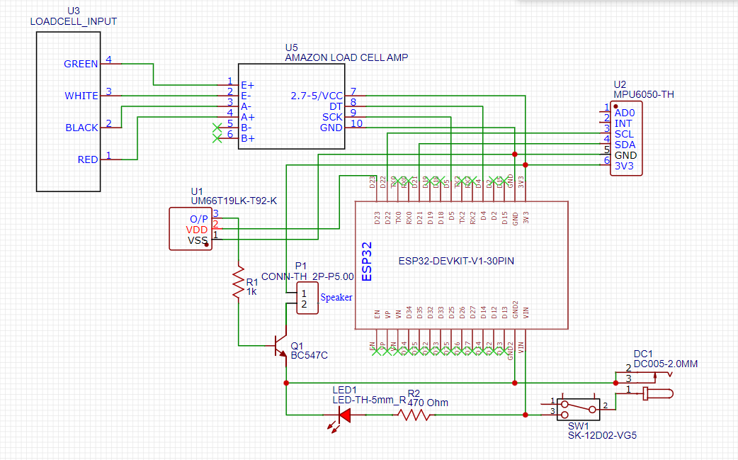
Fig2: Saline Level Indicator Transmitter Schematic Diagram

Working Procedure of the Saline Bottle Monitoring System
- Connect the power adapters to the transmitter board and switch on the power supply.
- Hang the saline bottle on the hook of the transmitter unit. The hook is connected to a load cell, which is interfaced with the ESP32 processor through an HX711 load cell amplifier.
- Set the threshold weight of the saline bottle to 30 grams.
- When the saline bottle's weight decreases below 30 grams, the transmitter activates slow music near the saline bottle to alert the patient or nearby attendants. Simultaneously, it sends a signal to the receiver module installed in the nurse's room.
- At the receiver unit in the nurse's room, the red LED glows and the buzzer sounds to alert the nurse that the saline bottle is nearly empty and requires attention.
- When the saline bottle's weight is above the threshold of 30 grams, no music is activated at the transmitter unit. However, a signal is sent to the receiver module, where the green LED glows, indicating that the saline bottle has not yet reached the low-weight threshold.
- An OLED display is provided at the receiver unit to display the communication status and other relevant information received from the transmitter, such as the saline bottle's weight and its status.
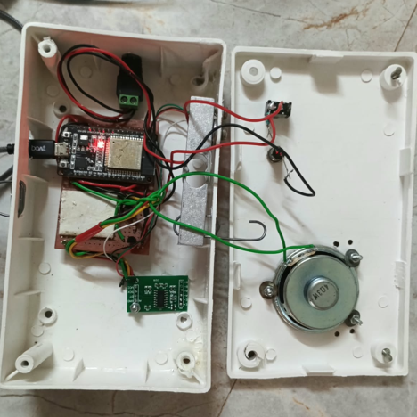
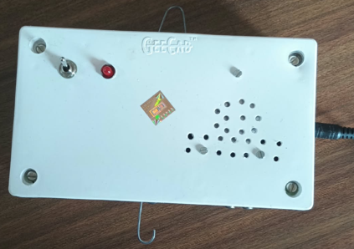

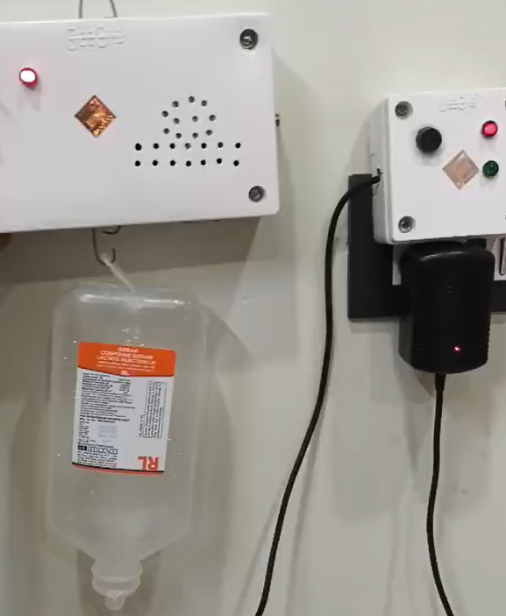

Receiver Module

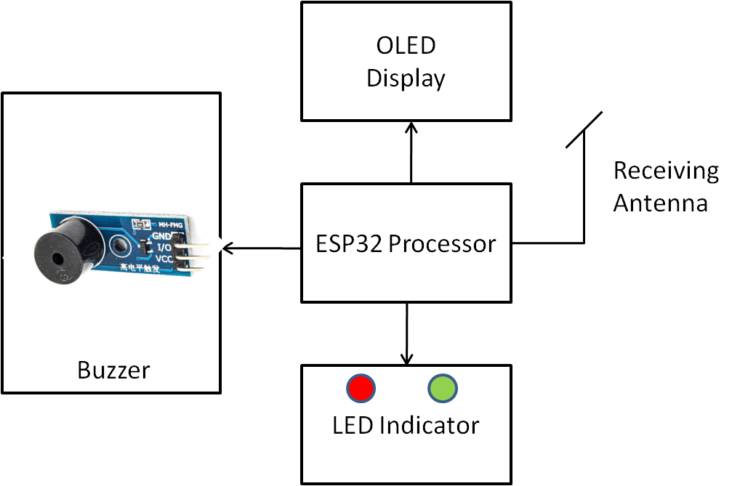
Fig2: Saline Level Indicator Receiver Block Diagram
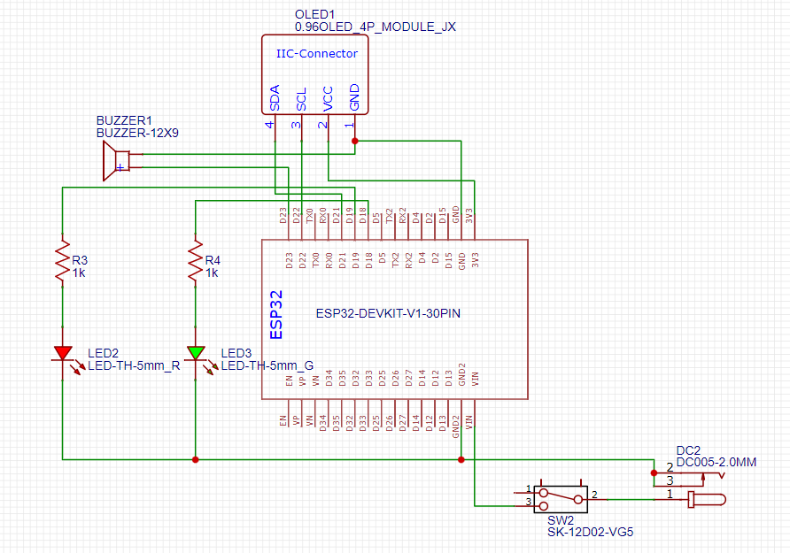
Fig4: Saline Level Indicator Receiver Schematic Diagram
